**:LAB_7:**

**Question 1**

Grant all privilege to user which name Ali.

**ANSWER:**

CREATE USER ‘Ali’@’localhost ‘ IDENTIFIED BY ‘123’

GRANT ALL PRIVILEGES ON lab5db,* TO ‘Ali’

**Question 2**

Grant only creates permission to user which name Fahad.

**ANSWER:**

CREATE USER ‘Fahad@’localhost ‘ IDENTIFIED BY ‘1234’

GRANT CREATE ON lab5db,* TO ‘Fahad’

|  |  |  |  |
| --- | --- | --- | --- |
| **Emp_num** | **Emp_Name** | **Emp_Job** | **Emp_Sal** |
| E101 | Salman | Analyst | 6000 |
| E102 | Bushra | Programmer | 5000 |
| E103 | Madiha | Web Designer | 6000 |
| E104 | Aiman | ERD designer | 4000 |
| E105 | Hameed | Web Designer | 3000 |
| E106 | Nini | Analyst | 2500 |
| E107 | Imtiaz | Web Designer | 6500 |
| E108 | Rashid | Programmer | 4000 |
| E109 | Muzzamil | ERD designer | 2000 |

**LAB_8:**

1. List all employees’ number, employee’s name and jobs from emp.

CREATE DATABASE employee

CREATE TABLE employee(

emp_no INT NOT NULL,

emp_name VARCHAR(50),

emp_job VARCHAR(50),

emp_salary INT

);

INSERT INTO employee(emp_no, emp_name, emp_job, emp_salary)

VALUE(101, 'Salman', 'Analyst', 6000),

(101, 'Bushra', 'Programmer', 5000),

(101, 'Madiha', 'Web Designer', 6000),

(101, 'Aiman', 'ERD designer', 4000),

(101, 'Hameed', 'Web Designer', 3000),

(101, 'Nini', 'Analyst', 2500),

(101, 'Imtiaz', 'Web Designer', 6500),

(101, 'Rashid', 'Programmer', 4000),

(101, 'Muzzamil', 'ERD designer', 2000)

SELECT emp_no, emp_name, emp_job

FROM employee

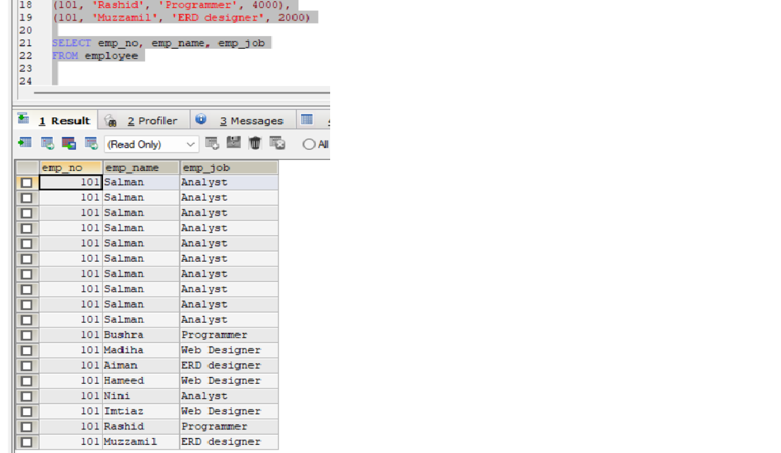

1. List all employees’ number, employee’s name and jobs from emp whose salaries greater than 5,000.

**ANSWER:**

SELECT emp_no, emp_name, emp_job, emp_salary

FROM employee

WHERE emp_salary>5000

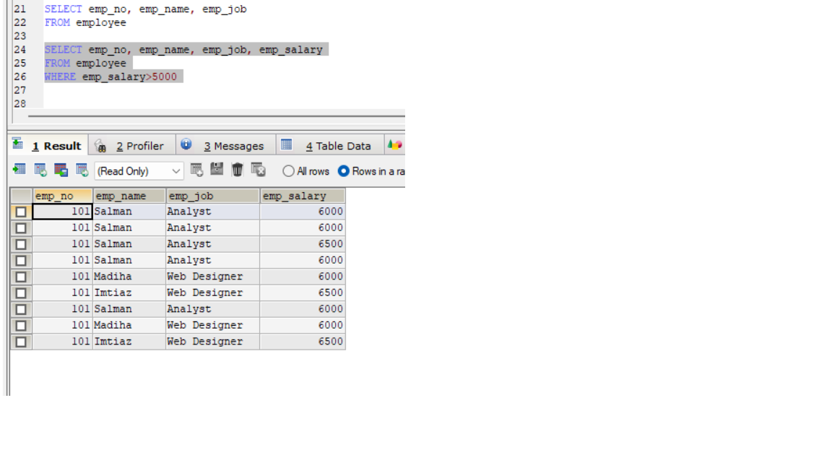

1. List all employees’ number, employee’s name and jobs from emp whose salaries less than 5,000.

**ANSWER:**

SELECT emp_no, emp_name, emp_job, emp_salary

FROM employee

WHERE emp_salary<5000

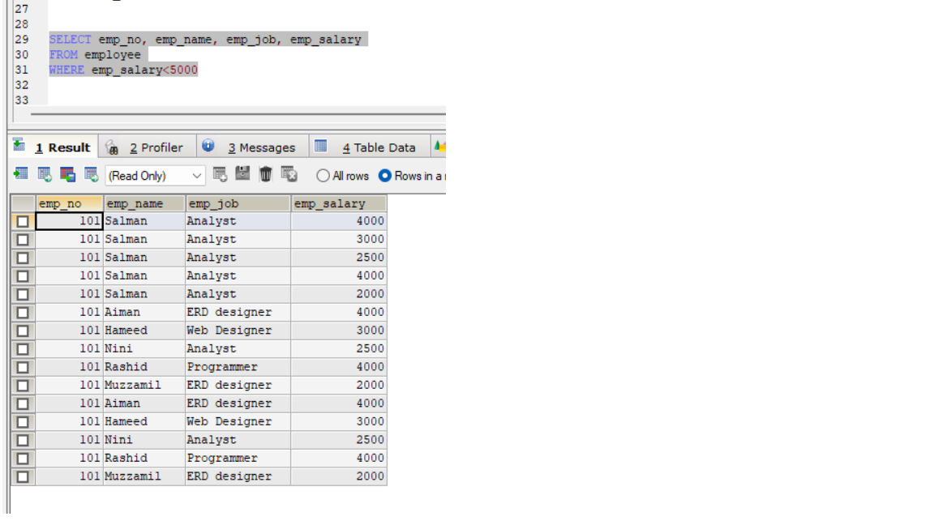

1. List all employees’ number, employee’s name and jobs from emp whose salaries between 1,000 to 5,000.

**ANSWER:**

SELECT emp_no, emp_name, emp_job, emp_salary

FROM employee

WHERE emp_salary BETWEEN 1000 AND 5000

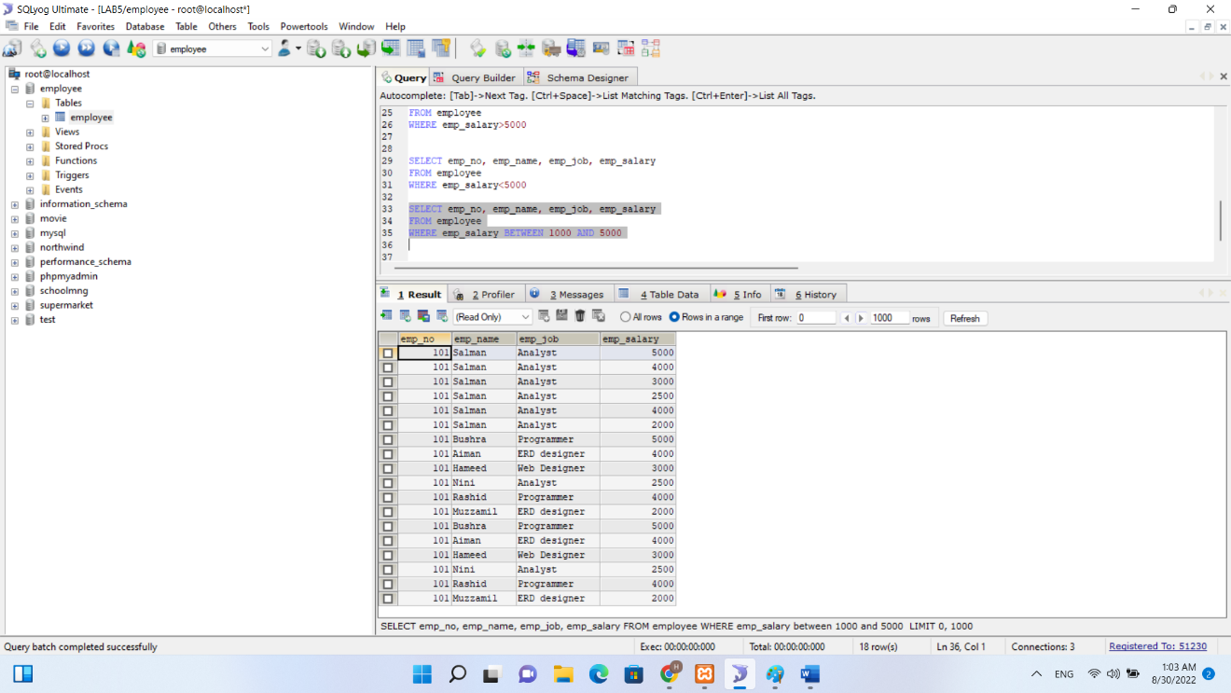

1. List all employees’ number, employee’s name, jobs and salaries from emp.

**ANSWER:**

SELECT *

FROM employee

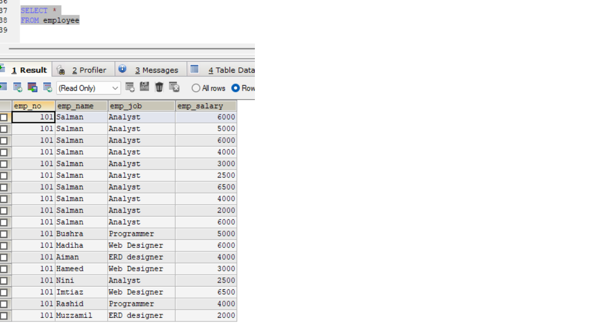

**LAB_9:**

1. List of all supplier that palced order.

**QUERIES:**

SELECT s.SupplierID, o.OrderID

FROM suppliers AS s, orders AS o

**OUTPUT:**



1. List of all Product that are supplied by supplier whose id is 101.

**QUERIES:**

SELECT S.S_NO,S.SUP_NAME,S.SUP_ADD,S.RANK,S.SUP_ID FROM ORDERS O INNER JOIN SUPPLIER S

ON O.SUP_ID=S.SUP_ID

**OUTPUT:**

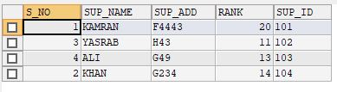

1. Find all order(s) of product named Rice.

**QUERIES:**

SELECT P.Prod_Name, O.ORD_ID,O.QTY

FROM ORDERS O LEFT JOIN PRODUCT P

ON O.PROD_ID=P.PROD_id WHERE P.Prod_Name='RICE'

**OUTPUT:**

**LAB_10:**

1. List average salary of each job.

**QUERIES/OUTPUT:**

select avg(salary) from customers as avgsalary;



1. Find average and sum of all the salaries of each job excluding clerks.

**QUERIES/OUTPUT:**

SELECT avg(SALARY),sum(SALARY)

FROM customer WHERE SALARY>all

( SELECT SALARY FROM customers WHERE dept ='clerk') and dept <>'clerk';



1. Find average and sum of the salaries of each job excluding salesmen', clerk' and 'manager'.

**QUERIES/OUTPUT:**

SELECT avg(SALARY),sum(SALARY)

FROM customers

WHERE SALARY>all ( SELECT SALARY FROM customers

WHERE dept ='clerk' and dept='manager') and dept <>'clerk';



1. Find count, sum and average salaries of each job excluding salesmen', clerk' and 'manager'.

**QURIES/OUTPUT:**

SELECT count(salary), avg(SALARY),sum(SALARY)

FROM customers

WHERE SALARY>all ( SELECT SALARY

FROM customers

WHERE dept ='clerk' and dept='manager') and dept <>'clerk';



1. List average salary of each department.

**QUERIES/OUTPUT:**

select avg(salary)

from customers as avgsalary

group by dept

;

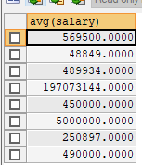

**LAB_11:**

1. Find the names of Top 10 employees which salaries are highest.

**QUERIES/OUTPUT:**

Ans. SELECT * FROM customers

ORDER BY salary DESC LIMIT 10;

